The current PartnerSync onboarding design is a solid technical foundation, but it is still closer to an application-and-provisioning workflow than a complete enterprise partner lifecycle.
The enhanced process should separate:
- Business qualification
- Risk and compliance assessment
- Commercial approval
- Salesforce partner enablement
- User provisioning
- Readiness and activation
- Ongoing governance
- Suspension and offboarding

1. Review of the current onboarding process
The existing design follows:
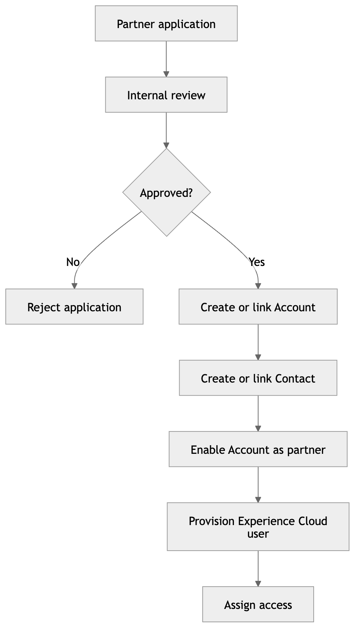
It already includes several good enterprise characteristics:
- Partner_Application__c as the onboarding record.
- Review and approval before account creation.
- Account and Contact matching to prevent duplicates.
- Controlled Experience Cloud user provisioning.
- Idempotent asynchronous provisioning.
- Thin profiles with permission sets or permission-set groups.
- Account-bound access through User → Contact → Account.
- Durable provisioning outcomes instead of silent failures.
- No forced changes to subscriber organisation-wide defaults.
- Sharing Sets for straightforward account access.
- Apex managed sharing for complex partner relationships.
However, several areas require enhancement.

2. Priority gaps
Priority | Gap | Enterprise impact
Critical | Approval is treated as one general decision | Legal, compliance, commercial and operational approvals cannot be independently audited
Critical | Business approval and technical activation are too closely coupled | A partner could receive access before contracts or compliance requirements are complete
Critical | Is_Partner__c can be confused with Salesforce Account.IsPartner | Partner Community user creation may fail even though the custom partner flag is true
Critical | No formal onboarding case or checklist aggregate | Tasks, evidence, decisions and exceptions become fragmented
High | Limited due-diligence model | Tax, sanctions, insurance, privacy, security and financial checks are not systematically governed
High | No contract-signature gate | Approval alone could incorrectly permit activation
High | Provisioning prerequisites are not modelled as explicit controls | Missing licences, roles, profiles or permission sets are discovered too late
High | No readiness assessment | A technically provisioned partner may be unable to transact correctly
High | No segregation-of-duties rules | One person could potentially assess, approve and activate the same partner
Medium | No SLA and escalation framework | Applications can remain unattended without management visibility
Medium | No formal renewal or recertification process | Partner information and compliance evidence can become stale
Medium | Suspension and offboarding are underdeveloped | Access, sharing and active deals may remain after termination

3. Recommended enterprise onboarding lifecycle

Stage 1 — Registration and identity verification
The prospective partner submits a Partner_Application__c.
Capture:
- Registered legal name and trading name
- Registration or company number
- Country and tax identifiers
- Business address
- Website and corporate email domain
- Primary and executive contacts
- Partner type and requested tier
- Regions and territories
- Products and services
- Technical capabilities
- Expected sales capacity
- Existing Salesforce Account reference, when known
- Consent, privacy notice acceptance and declarations
Controls:
- Duplicate detection using legal name, registration number, tax ID, website domain and address.
- Contact identity matching.
- Email verification.
- Required-document validation.
- Terms version and consent timestamp.
- Fraud and disposable-email indicators where appropriate.
The application should initially enter Submitted, not Approved.

Stage 2 — Triage and qualification
Partner operations evaluates whether the applicant meets minimum programme criteria.
Possible outcomes:
- Qualified
- More Information Required
- Not Qualified
- Duplicate or Existing Partner
- Withdrawn
The system should generate a qualification score, but the score should support—not replace—the reviewer’s decision.
Recommended criteria:
- Strategic alignment
- Market coverage
- Sales capability
- Technical certifications
- Implementation capacity
- Customer references
- Competing commitments
- Programme capacity
- Expected revenue contribution

Stage 3 — Due diligence and compliance
Create an onboarding assessment plan based on partner type, country, tier and risk.
Checks may include:
- Business registration verification
- Tax information
- Sanctions and restricted-party screening
- Anti-bribery and corruption declaration
- Conflict-of-interest declaration
- Data privacy assessment
- Information-security assessment
- Insurance verification
- Financial or credit assessment
- Beneficial ownership information
- Regulatory licensing where applicable
Each check needs:
- Owner
- Status
- Due date
- Evidence
- Outcome
- Expiry date
- Reviewer
- Decision timestamp
- Exception or waiver details
An expired or failed mandatory check must prevent activation.

Stage 4 — Multi-dimensional approval
Do not model this as a single Approved transition.
Recommended approval dimensions:
Approval dimension | Typical owner | Purpose
Business | Channel manager | Strategic and commercial suitability
Compliance | Compliance officer | Due-diligence acceptance
Legal | Legal representative | Contract and terms acceptance
Security | Security/privacy team | Data and system access suitability
Finance | Finance or credit team | Payment, tax and credit arrangements
Programme | Partner operations | Tier, territory and operational readiness
Use an approval plan containing independent approval steps. Completion of one step must not prematurely change the application to final approval.
Recommended application outcomes:
- Conditionally Approved
- Approved for Contracting
- Rejected
- Approval Expired
A waiver should require its own authority, justification and expiry date.

Stage 5 — Contracting
After business and risk approval:
- Generate or associate the partner agreement.
- Track agreement version.
- Track authorised signatories.
- Record signature status and effective date.
- Record programme terms and policies accepted.
- Capture territory, tier, discount structure and renewal date.
- Retain the executed agreement as controlled evidence.
Only a fully executed agreement should permit technical activation, unless an authorised exception exists.

Stage 6 — Account and relationship establishment
After contracting:
- Match an existing Salesforce Account.
- Create an Account only when no valid match exists.
- Match or create Contacts.
- create the partner programme relationship.
- Apply tier, region, partner type and lifecycle status.
- Establish parent, subsidiary or distributor relationships.
- Assign internal account ownership.
The Account should have separate fields for separate meanings:
- Is_Partner__c: PartnerSync business classification.
- Account.IsPartner: Salesforce platform enablement.
- Partner_Status__c: lifecycle status.
- Partner_Tier__c: current programme tier.
- Partner_Activation_Date__c: effective activation date.
- Partner_Review_Date__c: next governance review.
Do not use Is_Partner__c as evidence that Salesforce partner enablement has occurred.

Stage 7 — Salesforce partner enablement
This requires an explicit technical gate.
Before creating Partner Community-style users, verify:
- Account.IsPartner = true
- Appropriate Experience Cloud licence is available
- Required profile exists and supports the licence
- External role configuration is valid
- Required permission sets and permission-set groups exist
- Experience Cloud site is active
- Account and Contact are eligible
- Username and federation identity are unique
- Package configuration diagnostics pass
The safest baseline remains:
- An authorised administrator selects Manage External Account → Enable as Partner.
- PartnerSync records Partner Enablement Required.
- The administrator performs the enablement.
- PartnerSync rechecks Account.IsPartner.
- The administrator invokes Retry Provisioning.
Automation should only be offered through an explicitly supported, authorised and tested mechanism. PartnerSync should not assume that setting the custom Is_Partner__c enables the standard Salesforce partner capability.

Stage 8 — User access requests and provisioning
Provisioning should operate from a formal access request, not directly from application approval.
Recommended flow:
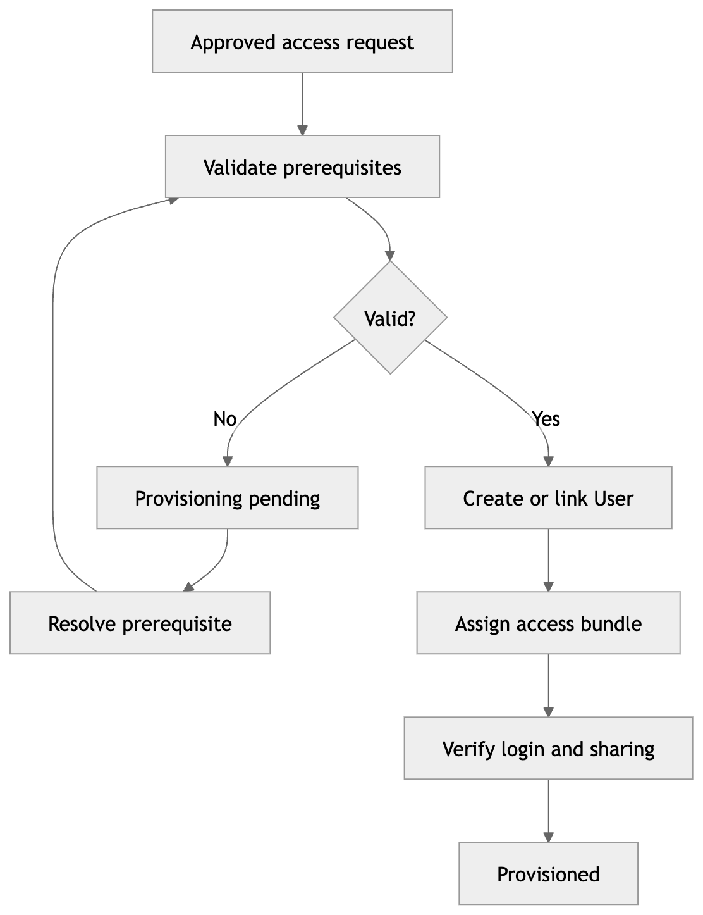
Controls:
- One access request per person and partner context.
- Licence compatibility validation.
- Permission-set-group assignment by role.
- No direct assignment of excessive profiles.
- Idempotency key for every provisioning request.
- Attempt history and error classification.
- Maximum retries with escalation.
- User creation reconciliation.
- Separate requester and approver where required.
- Access expiry for temporary users.
- Immediate disablement for withdrawn requests.
- Verification that the user can only see authorised account data.
Recommended access bundles:
- Partner Executive
- Partner Sales Manager
- Partner Sales User
- Partner Marketing/MDF User
- Partner Operations User
- Partner Content User
- Partner Administrator

Stage 9 — Readiness and activation
Creating the User must not automatically mean that the partner is operationally active.
Readiness gates should include:
- First administrator successfully logged in
- Mandatory training completed
- Programme policies accepted
- Partner profile completed
- Products and territories configured
- Deal registration training completed
- MDF training completed when applicable
- Support contacts confirmed
- Data-sharing test passed
- Internal channel owner assigned
- Launch checklist approved
Only then transition the partner to Active.

Stage 10 — Hypercare and ongoing governance
For the first 30–90 days:
- Monitor login and engagement.
- Track incomplete training.
- Track failed provisioning attempts.
- Review initial deal submissions.
- Monitor support cases.
- Schedule channel-manager check-ins.
- Escalate inactive partners.
- Measure time-to-first-value.
After hypercare:
- Annual or risk-based recertification
- Contract renewal
- Insurance/document expiry monitoring
- Permission review
- Partner tier reassessment
- Contact and administrator validation
- Dormant-account detection
- Compliance rescreening

Stage 11 — Suspension and offboarding
Partner lifecycle must support:
- Suspended
- Under Investigation
- Termination Pending
- Terminated
- Archived
Offboarding should:
- Freeze new deal and MDF submissions.
- Disable external Users.
- Remove permission-set assignments.
- Revoke complex managed-sharing grants.
- Preserve historical deal and audit data.
- Reassign open work.
- Resolve active opportunities and protected deals.
- revoke integration credentials.
- capture termination reason and authority.
- issue evidence of completed access removal.

4. Recommended state model
Do not place every lifecycle concern into one status field.
Aggregate | Example statuses
Partner application | Draft, Submitted, Qualification Review, Due Diligence, Approval In Progress, Approved for Contracting, Rejected, Withdrawn
Approval plan | Not Started, In Progress, Blocked, Approved, Rejected, Expired
Contract | Draft, Sent, Negotiation, Partially Signed, Executed, Expired, Terminated
Account enablement | Not Required, Required, Pending Admin Action, Enabled, Failed
User access request | Draft, Submitted, Approved, Provisioning, Provisioning Pending, Provisioned, Rejected, Revoked
Partner readiness | Not Started, In Progress, Blocked, Ready
Partner lifecycle | Prospect, Onboarding, Active, Suspended, Termination Pending, Terminated
This prevents an intermediate technical event from incorrectly moving the whole partner to Active.

5. Recommended data-model enhancements
Retain Partner_Application__c and add or formalise:
- Partner_Onboarding__c — master onboarding case
- Partner_Onboarding_Task__c — required work and checklist items
- Partner_Assessment__c — qualification, risk or readiness assessment
- Partner_Assessment_Finding__c — individual findings
- Partner_Approval_Plan__c
- Partner_Approval_Step__c
- Partner_Document__c — evidence metadata and expiry
- Partner_Agreement__c
- Partner_Access_Request__c
- Partner_Provisioning_Attempt__c
- Partner_Training_Assignment__c
- Partner_Relationship__c
- Partner_Lifecycle_Event__c
- Partner_Exception__c — waivers and approved exceptions
The actual documents can remain in Salesforce Files; Partner_Document__c should hold document type, verification, ownership, expiry and relationship metadata.

6. Service-layer enhancements
Recommended application services:
- PartnerApplicationService
- PartnerQualificationService
- PartnerDueDiligenceService
- PartnerApprovalPlanService
- PartnerAgreementService
- PartnerIdentityResolutionService
- PartnerAccountRelationshipService
- PartnerEnablementService
- PartnerAccessRequestService
- PartnerUserProvisioningService
- PartnerReadinessService
- PartnerLifecycleService
- PartnerOffboardingService
- PartnerOnboardingSLAService
The domain layer should own business rules, while services coordinate transactions and integrations.
Provisioning failures should be treated as durable business outcomes:
success: false
outcome: ProvisioningPending
reasonCode: ACCOUNT_NOT_PARTNER_ENABLED
retryAllowed: true
attemptPersisted: true
They should not simply throw an exception that rolls back the provisioning history.

7. Enterprise controls that should be mandatory
- Full lifecycle audit trail.
- Segregation of duties.
- Configurable approval authority.
- SLA timers and escalation.
- Idempotent commands.
- Duplicate Account, Contact and User prevention.
- Evidence retention and expiry.
- Durable validation findings.
- Explicit exception and waiver handling.
- Permission-set-group-based access.
- Licence and configuration diagnostics.
- Account-bound sharing verification.
- No package-driven OWD changes.
- No silent privilege escalation.
- Bulk-safe, retry-safe provisioning.
- Operational dashboards and failed-process queues.
- Suspension and offboarding automation.

Recommended decision
Adopt the enhanced lifecycle and keep the existing manual Salesforce partner-enablement step as the supported baseline:
Approve business relationship → execute agreement → establish Account and Contacts → authorised administrator enables Account as Partner → retry controlled provisioning → complete readiness checks → activate partner.
This is more suitable for an enterprise implementation because business approval, legal acceptance, Salesforce enablement, user provisioning and operational activation become distinct, auditable gates rather than one overloaded “Approved” action.
Yes—document submission and electronic document execution are essential parts of the enterprise PartnerSync onboarding process.
They should form a controlled document and agreement workstream, not be handled as ordinary file attachments.
Typical documents include:
- Business registration and tax evidence
- Insurance certificates
- Financial or credit information
- Security and privacy questionnaires
- Anti-bribery, sanctions and conflict-of-interest declarations
- Regulatory licences and certifications
- Partner programme application
- Non-disclosure agreement
- Partner agreement
- Data processing agreement
- Territory, pricing or commercial schedules
- Programme policies and terms
- Training certificates
The process should support three distinct capabilities:
- Document submission
The applicant uploads evidence through Experience Cloud using Salesforce Files.
- Document review and verification
Internal reviewers accept, reject, request replacement, record findings, and monitor expiry dates.
- Electronic agreement execution
PartnerSync generates or selects the correct agreement, sends it to authorised signatories, tracks signatures, and retains the final executed copy and audit certificate.
Recommended lifecycle:
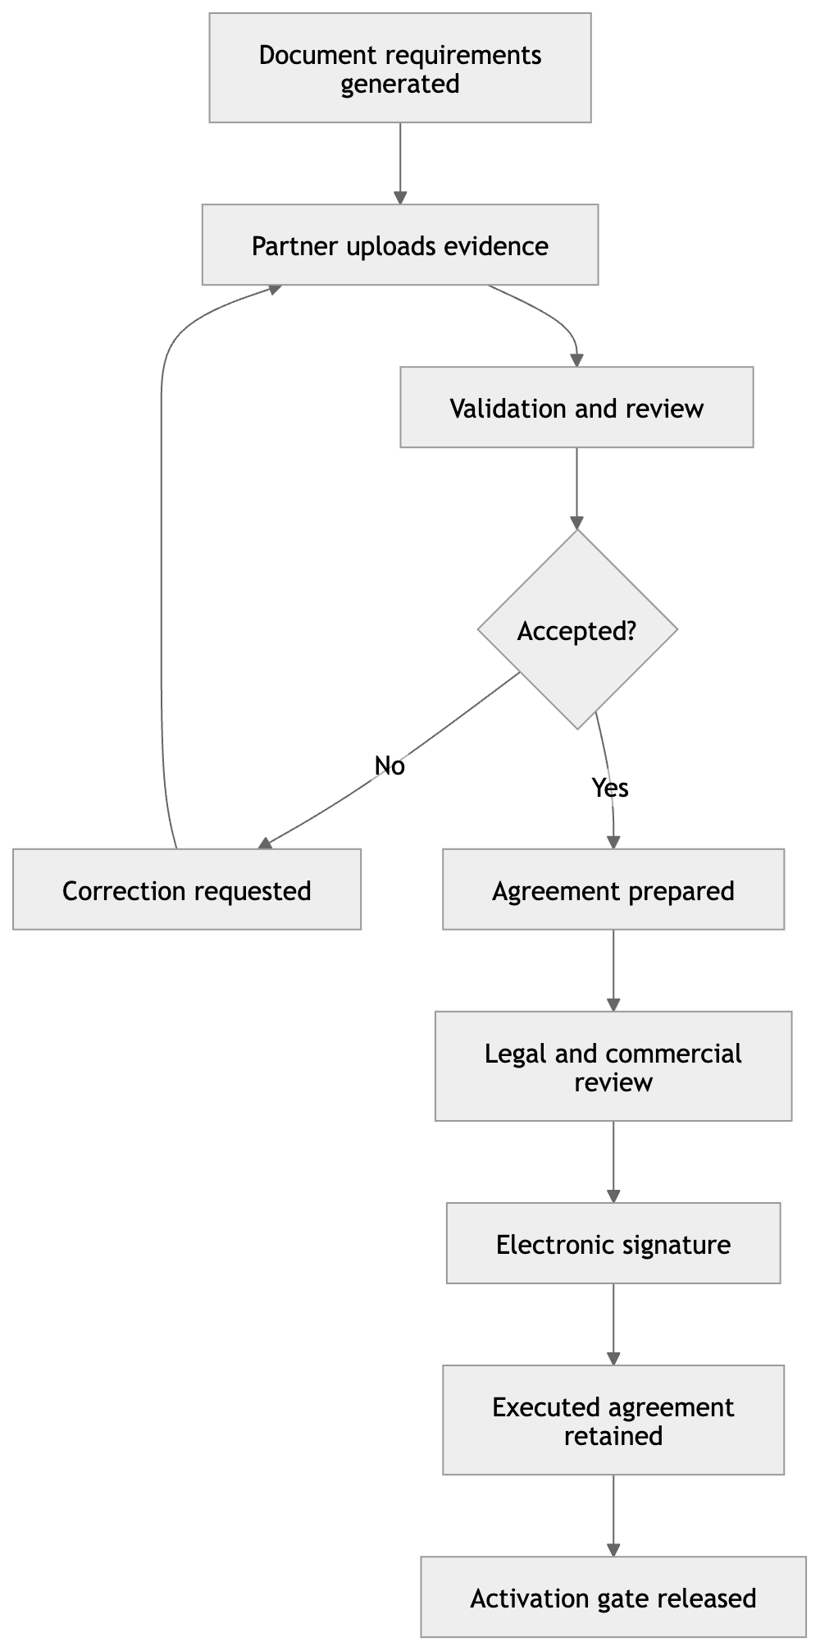
PartnerSync should add or formalise:
Record | Responsibility
Partner_Document_Requirement__c | Defines documents required according to country, partner type, tier and risk
Partner_Document__c | Tracks each submitted document, its review, version and expiry
Partner_Agreement__c | Controls agreement type, version, parties, status and effective dates
Partner_Agreement_Signatory__c | Tracks each required internal or external signatory
Partner_Document_Review__c | Preserves reviewer decisions, findings and replacement requests
Partner_Consent__c | Records declarations, policy acceptance and terms versions
Partner_Exception__c | Records approved waivers for missing or exceptional evidence
The binary file should remain in Salesforce Files. The custom records provide the enterprise controls around that file: classification, ownership, review status, version, expiry, confidentiality and auditability.
Agreement states should be independent from application approval:
Draft → Internal Review → Approved for Signature → Sent → Viewed → Partially Signed → Executed → Effective → Expired/Terminated
Activation should require a rule such as:
Application approval complete
AND all mandatory documents accepted
AND all blocking findings resolved
AND required agreements executed and effective
AND no expired mandatory evidence
AND no unresolved legal or compliance exception
For electronic signatures, PartnerSync should use a provider integration such as DocuSign or Adobe Acrobat Sign rather than attempting to implement legally reliable signatures itself. PartnerSync remains the orchestration and system-of-record layer, while the signature provider handles identity authentication, signature evidence, signing order, timestamps and completion certificates.
Important enterprise controls include:
- Malware scanning and file-type restrictions
- File-size and upload controls
- Encryption and least-privilege access
- Document classification and confidentiality level
- Required-document rules driven by metadata
- Version and supersession history
- Expiry reminders and recertification
- Authorised-signatory verification
- Signing sequence and countersignature
- Immutable execution audit evidence
- Retention and legal-hold policies
- Withdrawal and replacement without erasing history
- Webhook idempotency and signature validation
- Data residency and privacy controls
- Manual fallback when an integration is unavailable
So the correct enterprise sequence is:
Submit application → determine document requirements → collect and verify evidence → complete approvals → prepare and execute agreements → establish the partner relationship → enable Salesforce partner capability → provision users → complete readiness → activate.
A partner must not become Active merely because their application was approved. The required documents must be accepted and the applicable agreements must be fully executed first.

---------------
The “Recommended enterprise onboarding lifecycle” must be updated so document submission, verification, legal preparation, and electronic execution are first-class lifecycle stages—not minor activities hidden inside due diligence or contracting.

Updated enterprise onboarding lifecycle

Yes—document submission and electronic document execution are essential parts of the enterprise PartnerSync onboarding process.
They should form a controlled document and agreement workstream, not be handled as ordinary file attachments.
Typical documents include:
- Business registration and tax evidence
- Insurance certificates
- Financial or credit information
- Security and privacy questionnaires
- Anti-bribery, sanctions and conflict-of-interest declarations
- Regulatory licences and certifications
- Partner programme application
- Non-disclosure agreement
- Partner agreement
- Data processing agreement
- Territory, pricing or commercial schedules
- Programme policies and terms
- Training certificates
The process should support three distinct capabilities:
- Document submission
The applicant uploads evidence through Experience Cloud using Salesforce Files.
- Document review and verification
Internal reviewers accept, reject, request replacement, record findings, and monitor expiry dates.
- Electronic agreement execution
PartnerSync generates or selects the correct agreement, sends it to authorised signatories, tracks signatures, and retains the final executed copy and audit certificate.
Recommended lifecycle:
PartnerSync should add or formalise:
Record | Responsibility
Partner_Document_Requirement__c | Defines documents required according to country, partner type, tier and risk
Partner_Document__c | Tracks each submitted document, its review, version and expiry
Partner_Agreement__c | Controls agreement type, version, parties, status and effective dates
Partner_Agreement_Signatory__c | Tracks each required internal or external signatory
Partner_Document_Review__c | Preserves reviewer decisions, findings and replacement requests
Partner_Consent__c | Records declarations, policy acceptance and terms versions
Partner_Exception__c | Records approved waivers for missing or exceptional evidence
The binary file should remain in Salesforce Files. The custom records provide the enterprise controls around that file: classification, ownership, review status, version, expiry, confidentiality and auditability.
Agreement states should be independent from application approval:
Draft → Internal Review → Approved for Signature → Sent → Viewed → Partially Signed → Executed → Effective → Expired/Terminated
Activation should require a rule such as:
Application approval complete
AND all mandatory documents accepted
AND all blocking findings resolved
AND required agreements executed and effective
AND no expired mandatory evidence
AND no unresolved legal or compliance exception
For electronic signatures, PartnerSync should use a provider integration such as DocuSign or Adobe Acrobat Sign rather than attempting to implement legally reliable signatures itself. PartnerSync remains the orchestration and system-of-record layer, while the signature provider handles identity authentication, signature evidence, signing order, timestamps and completion certificates.
Important enterprise controls include:
- Malware scanning and file-type restrictions
- File-size and upload controls
- Encryption and least-privilege access
- Document classification and confidentiality level
- Required-document rules driven by metadata
- Version and supersession history
- Expiry reminders and recertification
- Authorised-signatory verification
- Signing sequence and countersignature
- Immutable execution audit evidence
- Retention and legal-hold policies
- Withdrawal and replacement without erasing history
- Webhook idempotency and signature validation
- Data residency and privacy controls
- Manual fallback when an integration is unavailable
So the correct enterprise sequence is:
Submit application → determine document requirements → collect and verify evidence → complete approvals → prepare and execute agreements → establish the partner relationship → enable Salesforce partner capability → provision users → complete readiness → activate.
A partner must not become Active merely because their application was approved. The required documents must be accepted and the applicable agreements must be fully executed first.

However, we should update the Recommended enterprise onboarding lifecycle to include or integrate the document submission and electronic document execution

The “Recommended enterprise onboarding lifecycle” must be updated so document submission, verification, legal preparation, and electronic execution are first-class lifecycle stages—not minor activities hidden inside due diligence or contracting.

Updated enterprise onboarding lifecycle

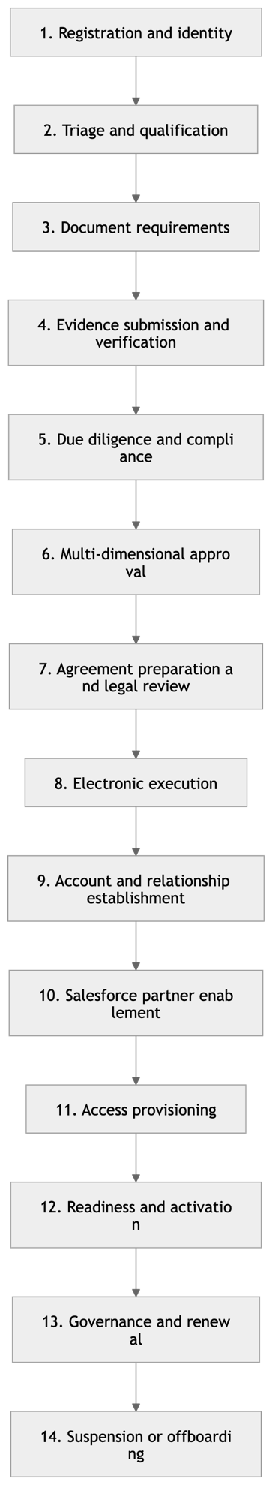

Stage 1 — Registration and identity verification
The applicant submits the initial Partner_Application__c, including:
- Legal and trading names
- Company and tax registration numbers
- Business and registered addresses
- Corporate website and email domain
- Primary and executive contacts
- Partner type, requested tier and territories
- Products, services and capabilities
- Privacy consent and initial declarations
Initial duplicate detection, email verification, identity matching and application validation occur here.

Stage 2 — Triage and qualification
Partner Operations evaluates strategic and programme suitability.
Possible outcomes:
- Qualified
- More Information Required
- Not Qualified
- Duplicate or Existing Partner
- Withdrawn
Qualification decides whether the organisation proceeds into formal evidence collection and due diligence.

Stage 3 — Document requirement determination
PartnerSync generates a document requirement plan based on:
- Country and legal jurisdiction
- Partner type
- Requested tier
- Products and services
- Data-access requirements
- Industry and regulatory exposure
- Financial or credit requirements
- Risk classification
- Programme configuration
Example requirements include:
- Business registration evidence
- Tax documentation
- Insurance certificates
- Regulatory licences
- Financial information
- Beneficial-ownership declarations
- Anti-bribery and conflict declarations
- Security and privacy questionnaires
- Certifications and customer references
Each requirement must identify whether it is:
- Mandatory, conditional or optional
- Blocking or non-blocking
- Required before approval, contracting or activation
- Subject to expiry or renewal
- Eligible for a waiver

Stage 4 — Document submission and verification
The partner submits evidence through Experience Cloud. The binary files remain in Salesforce Files, while PartnerSync records control metadata.
Each document should support:
- Upload and submission
- Document-type classification
- Versioning and replacement
- Malware and file-type validation
- Internal review
- Acceptance or rejection
- Correction requests
- Findings and reviewer comments
- Effective and expiry dates
- Confidentiality classification
- Supersession without deleting history
Recommended states:
Required → Awaiting Submission → Submitted → Under Review → Accepted / Rejected / Replacement Required → Superseded / Expired
A rejected document should return to the partner with a reason and resubmission instructions. Previous versions must remain auditable.

Stage 5 — Due diligence and compliance
Due-diligence checks consume the submitted and verified evidence.
Checks can include:
- Corporate-registration verification
- Tax validation
- Sanctions and restricted-party screening
- Beneficial-ownership review
- Anti-bribery assessment
- Conflict-of-interest review
- Financial or credit assessment
- Insurance verification
- Information-security assessment
- Privacy and data-protection assessment
- Regulatory licensing verification
Document acceptance does not automatically mean that the associated compliance check passed. These are separate decisions:
- The document may be authentic and complete.
- The information inside it may still produce a compliance finding.
Every finding must be persisted and resolved, accepted or formally waived.

Stage 6 — Multi-dimensional approval
Independent approval dimensions remain necessary:
Approval | Typical owner | Document dependency
Business | Channel manager | Capability and reference evidence
Compliance | Compliance officer | Declarations and due-diligence evidence
Legal | Legal representative | Corporate documents and proposed terms
Security/privacy | Security or privacy team | Questionnaires and supporting controls
Finance | Finance or credit team | Tax, banking and financial evidence
Programme | Partner Operations | Complete onboarding and tier requirements
Completing an approval step must update the approval plan, not prematurely set the entire partner application to approved.
Possible final outcomes:
- Conditionally Approved
- Approved for Contracting
- Rejected
- More Information Required
- Approval Expired

Stage 7 — Agreement preparation and legal review
Once the prerequisite approvals and documents are complete, PartnerSync prepares the required legal instruments.
These may include:
- Non-disclosure agreement
- Partner programme agreement
- Data processing agreement
- Security schedule
- Territory schedule
- Pricing or discount schedule
- Service or support schedule
- Code of conduct
- Programme policies and terms
This stage should:
- Select the correct template and version.
- Merge approved partner data.
- Identify the contracting legal entities.
- Identify authorised signatories.
- Route the draft through internal legal and commercial review.
- Manage negotiation and amendments.
- Lock the approved execution version.
- Release it for signature.
Negotiated clauses, deviations and concessions should be recorded rather than hidden in email exchanges.

Stage 8 — Electronic document execution
PartnerSync orchestrates the signature process through an electronic-signature provider such as DocuSign or Adobe Acrobat Sign.
Recommended agreement lifecycle:
Draft → Internal Review → Negotiation → Approved for Signature → Sent → Viewed → Partially Signed → Executed → Effective → Expired / Terminated
Electronic execution must support:
- External and internal signatories
- Signing order
- Countersignature
- Signatory authentication
- Reminder and expiry rules
- Decline and void outcomes
- Envelope or transaction correlation
- Webhook signature validation
- Idempotent event processing
- Executed-document retrieval
- Completion certificate retention
- Timestamp and audit evidence
- Manual reconciliation and fallback
Executed and Effective should remain distinct. An agreement can be fully signed on 5 August but become effective on 1 September.

Stage 9 — Account and relationship establishment
Only after required agreements are executed—or an authorised exception exists—should PartnerSync:
- Match or create the Account
- Match or create Contacts
- Establish the partner programme relationship
- Assign tier, territory and partner type
- Set internal ownership
- Create parent, subsidiary or distributor relationships
- Establish contract and renewal dates
This stage establishes the business relationship but does not yet create external-user access.

Stage 10 — Salesforce partner enablement
PartnerSync verifies:
- Required agreement is effective
- Mandatory documents remain accepted and valid
- No blocking legal or compliance finding exists
- Account.IsPartner = true
- Experience Cloud licences are available
- Profiles and access bundles are compatible
- Site and external-role configuration are valid
The supported baseline remains:
Authorised administrator enables the Account as Partner → PartnerSync verifies Account.IsPartner → controlled provisioning continues.

Stage 11 — Access request and provisioning
Provisioning operates from an approved Partner_Access_Request__c, not directly from application approval.
Each access request identifies:
- Person
- Partner Account
- Requested external role
- Access bundle
- Business justification
- Approver
- Start and expiry dates
- Provisioning and reconciliation status
User creation, permission assignment and sharing verification must be idempotent and auditable.

Stage 12 — Readiness and activation
Before the partner becomes Active, verify:
- Agreement is executed and effective
- Mandatory documents are accepted and unexpired
- Training is complete
- First partner administrator has logged in
- Partner profile is complete
- Products and territories are configured
- Support contacts are confirmed
- Sharing verification passed
- Internal channel owner is assigned
- Launch checklist is approved

Stage 13 — Ongoing governance, renewal and recertification
The document and agreement workstream continues after onboarding.
PartnerSync should monitor:
- Insurance and licence expiry
- Annual declarations
- Contract renewal dates
- Policy and programme-term updates
- Compliance rescreening
- Security reassessments
- Contact and signatory changes
- Access recertification
- Document replacement
- Agreement amendments and renewals
An expired mandatory document can place the partner into a restricted or suspended state according to configurable policy.

Stage 14 — Suspension, termination and offboarding
Suspension or termination should:
- Prevent new deals and MDF submissions
- Disable or restrict partner users
- Revoke managed-sharing grants
- Terminate or expire agreements
- Preserve executed documents and audit certificates
- Apply retention and legal-hold requirements
- Reassign open work
- Revoke integration credentials
- Record the decision authority and reason
- Produce access-removal evidence

Updated activation gate
A partner can become active only when:
Qualification completed
AND due diligence completed
AND all required approval steps completed
AND all mandatory documents accepted and unexpired
AND all blocking findings resolved
AND all required agreements executed and effective
AND no unresolved blocking exception exists
AND Salesforce partner enablement completed
AND required users successfully provisioned
AND readiness checklist completed

Required data-model additions
Object | Purpose
Partner_Document_Requirement__c | Defines each required evidence item and its gate
Partner_Document__c | Controls the submitted Salesforce File, version, status and expiry
Partner_Document_Review__c | Preserves verification decisions and findings
Partner_Agreement__c | Controls agreement type, version, parties and lifecycle
Partner_Agreement_Signatory__c | Identifies required signatories and signing order
Partner_Agreement_Event__c | Stores signature-provider events and reconciliation outcomes
Partner_Consent__c | Records declarations, policy acceptance and terms versions
Partner_Exception__c | Governs document, legal and compliance waivers
The corrected enterprise sequence is therefore:
Register → qualify → determine document requirements → submit and verify evidence → complete due diligence → obtain approvals → prepare and legally review agreements → execute electronically → establish the partner relationship → enable Salesforce partner capability → provision users → verify readiness → activate.

Below is the recommended enterprise-ready field model. Salesforce standard fields—Id, CreatedDate, CreatedById, LastModifiedDate, LastModifiedById, OwnerId, and SystemModstamp—are assumed and are not repeated.

1. Partner_Document_Requirement__c
Defines an evidence requirement generated for a specific onboarding, application, agreement, or ongoing compliance review.
Field API name | Type | Required | Purpose
Name | Auto Number PDR-{000000} | Yes | Requirement identifier
Partner_Onboarding__c | Master-Detail/Lookup | Yes | Parent onboarding case
Partner_Application__c | Lookup | No | Related application
Partner_Account__c | Lookup(Account) | No | Established partner Account
Requirement_Code__c | Text(80) | Yes | Stable requirement code
Document_Type__c | Picklist | Yes | Required evidence category
Display_Name__c | Text(255) | Yes | Partner-facing requirement name
Description__c | Long Text Area | No | Instructions and evidence expectations
Requirement_Source__c | Picklist | Yes | Programme, Legal, Compliance, Security, Finance, Regulatory, Manual
Requirement_Rule_Key__c | Text(255) | No | Metadata/rule that generated the requirement
Requirement_Level__c | Picklist | Yes | Mandatory, Conditional, Optional
Gate__c | Picklist | Yes | Qualification, Due Diligence, Approval, Contracting, Activation, Renewal
Is_Blocking__c | Checkbox | Yes | Prevents gate completion when unsatisfied
Waiver_Allowed__c | Checkbox | Yes | Whether an exception may satisfy the requirement
Status__c | Picklist | Yes | Not Required, Required, Awaiting Submission, Submitted, Under Review, Accepted, Rejected, Replacement Required, Waived, Expired, Cancelled
Requested_On__c | DateTime | No | Requirement issue timestamp
Required_By__c | Date | No | Evidence submission deadline
Reminder_Date__c | Date | No | Next reminder date
Escalation_Date__c | Date | No | SLA escalation date
Expiry_Required__c | Checkbox | Yes | Indicates evidence must have an expiry
Minimum_Validity_Days__c | Number(5,0) | No | Minimum remaining validity required
Renewal_Lead_Days__c | Number(5,0) | No | Days before expiry to request replacement
Jurisdiction__c | Text(80) | No | Country, state, or legal jurisdiction
Applicable_Partner_Type__c | Picklist/Multi-Select | No | Partner types to which it applies
Applicable_Tier__c | Picklist/Multi-Select | No | Applicable programme tiers
Confidentiality_Level__c | Picklist | Yes | Public, Internal, Confidential, Highly Confidential, Restricted
Submission_Count__c | Roll-Up Summary/Number | No | Number of submitted document records
Current_Document__c | Lookup(Partner_Document__c) | No | Current accepted or latest submission
Satisfied_On__c | DateTime | No | When the requirement was satisfied
Satisfied_By__c | Lookup(User) | No | User who confirmed satisfaction
Exception__c | Lookup(Partner_Exception__c) | No | Approved waiver satisfying the requirement
Generation_Idempotency_Key__c | Text(255), Unique | No | Prevents duplicate requirement generation
Internal_Notes__c | Long Text Area | No | Internal operational notes
Recommended Document_Type__c values:
- Business Registration
- Tax Registration
- Insurance Certificate
- Regulatory Licence
- Financial Statement
- Bank Verification
- Beneficial Ownership Declaration
- Anti-Bribery Declaration
- Conflict-of-Interest Declaration
- Security Questionnaire
- Privacy Questionnaire
- Data Protection Evidence
- Certification
- Customer Reference
- Training Certificate
- Other

2. Partner_Document__c
Controls each submitted evidence item while Salesforce Files retains the actual binary document.
Field API name | Type | Required | Purpose
Name | Auto Number PDOC-{000000} | Yes | Controlled-document identifier
Partner_Document_Requirement__c | Master-Detail/Lookup | Yes | Requirement being satisfied
Partner_Onboarding__c | Lookup | Yes | Related onboarding case
Partner_Application__c | Lookup | No | Related partner application
Partner_Account__c | Lookup(Account) | No | Established partner
Document_Type__c | Picklist | Yes | Evidence classification
Title__c | Text(255) | Yes | Business document title
Document_Number__c | Text(100) | No | Registration, licence, policy, or certificate number
Issuing_Authority__c | Text(255) | No | Organisation that issued the document
Jurisdiction__c | Text(80) | No | Governing jurisdiction
Content_Document_Id__c | Text(18) | Yes | Current Salesforce ContentDocument ID
Content_Version_Id__c | Text(18) | Yes | Submitted ContentVersion ID
File_Version_Number__c | Number(8,0) | No | Salesforce File version
Controlled_Version__c | Text(30) | Yes | Business version, such as 1.0 or 2.1
Status__c | Picklist | Yes | Draft, Uploaded, Submitted, Validation Failed, Under Review, Accepted, Rejected, Replacement Required, Superseded, Expired, Withdrawn, Quarantined
Submission_Source__c | Picklist | Yes | Experience Cloud, Internal User, Integration, Migration
Submitted_By_Contact__c | Lookup(Contact) | No | External submitter
Submitted_By_User__c | Lookup(User) | No | Salesforce User who submitted it
Submitted_On__c | DateTime | Yes | Formal submission timestamp
Document_Date__c | Date | No | Date appearing on the evidence
Effective_Date__c | Date | No | Validity commencement date
Expiry_Date__c | Date | No | Evidence expiry date
Days_Until_Expiry__c | Formula(Number) | No | Remaining validity
Expiry_Status__c | Formula/Picklist | No | Current, Expiring Soon, Expired, No Expiry
Verified_Status__c | Picklist | Yes | Not Verified, Pending, Verified, Verification Failed
Verified_On__c | DateTime | No | Final verification timestamp
Verified_By__c | Lookup(User) | No | Final verifier
Latest_Review__c | Lookup(Partner_Document_Review__c) | No | Current review outcome
Confidentiality_Level__c | Picklist | Yes | Public, Internal, Confidential, Highly Confidential, Restricted
Contains_Personal_Data__c | Checkbox | Yes | Privacy classification
Contains_Sensitive_Data__c | Checkbox | Yes | Sensitive or regulated information flag
Malware_Scan_Status__c | Picklist | Yes | Not Scanned, Pending, Clean, Threat Detected, Scan Failed
Malware_Scanned_On__c | DateTime | No | Scan completion timestamp
File_Hash__c | Text(128) | No | Integrity/deduplication hash
Mime_Type__c | Text(100) | No | Submitted MIME type
File_Size_Bytes__c | Number(18,0) | No | File size
Supersedes_Document__c | Lookup(Partner_Document__c) | No | Previous controlled document
Superseded_By_Document__c | Lookup(Partner_Document__c) | No | Replacement document
Is_Current_Version__c | Checkbox | Yes | Identifies current controlled version
Retention_Category__c | Picklist | No | Retention policy category
Retention_Until__c | Date | No | Earliest permitted disposal date
Legal_Hold__c | Checkbox | Yes | Prevents deletion or disposal
External_Reference__c | Text(255) | No | External repository/provider reference
Submission_Idempotency_Key__c | Text(255), Unique | No | Prevents duplicate processing
Rejection_Reason__c | Long Text Area | No | Partner-facing rejection explanation
Internal_Notes__c | Long Text Area | No | Restricted internal notes
ContentDocumentLink should link the Salesforce File to both Partner_Document__c and the appropriate onboarding or Account record, subject to confidentiality controls.

3. Partner_Document_Review__c
Creates an immutable history of verification decisions, findings, and replacement requests.
Field API name | Type | Required | Purpose
Name | Auto Number PDRV-{000000} | Yes | Review identifier
Partner_Document__c | Master-Detail | Yes | Document being reviewed
Partner_Document_Requirement__c | Lookup | Yes | Requirement being evaluated
Review_Type__c | Picklist | Yes | Completeness, Authenticity, Legal, Compliance, Security, Finance, Expiry, Final Verification
Review_Sequence__c | Number(5,0) | Yes | Review iteration
Status__c | Picklist | Yes | Assigned, In Progress, Completed, Cancelled
Decision__c | Picklist | No | Accepted, Rejected, Replacement Required, Accepted with Conditions, Escalated, Not Applicable
Outcome_Code__c | Picklist/Text | No | Standardised machine-readable outcome
Reviewer__c | Lookup(User) | Yes | Assigned reviewer
Reviewer_Team__c | Picklist | No | Legal, Compliance, Security, Finance, Partner Operations
Assigned_On__c | DateTime | No | Review assignment time
Due_Date__c | DateTime | No | Review SLA
Started_On__c | DateTime | No | Review commencement
Completed_On__c | DateTime | No | Decision timestamp
Finding_Severity__c | Picklist | No | Information, Low, Medium, High, Critical
Finding_Category__c | Picklist | No | Missing Information, Invalid Evidence, Authenticity Concern, Expired, Policy Conflict, Regulatory Concern, Security Concern, Other
Finding_Details__c | Long Text Area | No | Review finding
Partner_Feedback__c | Long Text Area | No | Sanitised explanation visible to partner
Correction_Required__c | Checkbox | Yes | Indicates corrective action is needed
Correction_Due_Date__c | Date | No | Replacement or remediation deadline
Blocking_Finding__c | Checkbox | Yes | Prevents the relevant lifecycle gate
Resolution_Status__c | Picklist | Yes | Not Required, Open, In Remediation, Resolved, Risk Accepted, Waived
Resolution_Details__c | Long Text Area | No | How the finding was resolved
Resolved_By__c | Lookup(User) | No | Resolution authority
Resolved_On__c | DateTime | No | Resolution timestamp
Exception__c | Lookup(Partner_Exception__c) | No | Approved exception for the finding
Superseded_Review__c | Lookup(Partner_Document_Review__c) | No | Earlier review replaced by this decision
Decision_Version__c | Number(5,0) | Yes | Supports immutable decision history
Record_Locked__c | Checkbox | Yes | Indicates completed review must not be edited
Review_Idempotency_Key__c | Text(255), Unique | No | Prevents duplicated automated reviews
A completed review should not be overwritten. Corrections should create a new document version and a new review record.

4. Partner_Agreement__c
Controls each NDA, partner agreement, DPA, schedule, amendment, renewal, or other legal instrument.
Field API name | Type | Required | Purpose
Name | Auto Number PAGR-{000000} | Yes | Agreement identifier
Agreement_Number__c | Text(80), Unique | Yes | Business-facing agreement number
Partner_Onboarding__c | Lookup | No | Related onboarding case
Partner_Application__c | Lookup | No | Source application
Partner_Account__c | Lookup(Account) | Yes | Contracting partner
Agreement_Type__c | Picklist | Yes | NDA, Partner Programme Agreement, DPA, Security Schedule, Commercial Schedule, Territory Schedule, Amendment, Renewal, Termination, Other
Agreement_Subtype__c | Text/Picklist | No | Additional classification
Agreement_Title__c | Text(255) | Yes | Agreement title
Template_Code__c | Text(100) | No | Source template identifier
Template_Version__c | Text(30) | No | Approved template version
Agreement_Version__c | Text(30) | Yes | Controlled legal version
Status__c | Picklist | Yes | Draft, Internal Review, Negotiation, Approved for Signature, Sent, Viewed, Partially Signed, Executed, Effective, Declined, Voided, Expired, Terminated, Superseded
Internal_Legal_Entity__c | Lookup(Account)/Text | Yes | Internal contracting entity
Partner_Legal_Entity_Name__c | Text(255) | Yes | External legal entity named in agreement
Partner_Registration_Number__c | Text(100) | No | Contracting entity registration number
Governing_Law__c | Text(100) | No | Governing law
Jurisdiction__c | Text(100) | No | Dispute/legal jurisdiction
CurrencyIsoCode | Standard Currency | No | Agreement currency
Contract_Value__c | Currency | No | Applicable commercial value
Term_Months__c | Number(5,0) | No | Contract term
Proposed_Effective_Date__c | Date | No | Intended effective date
Executed_Date__c | Date | No | Date all required signatures completed
Effective_Date__c | Date | No | Legal effectiveness date
Expiry_Date__c | Date | No | Agreement expiry
Renewal_Date__c | Date | No | Renewal action date
Renewal_Type__c | Picklist | No | None, Manual, Automatic
Notice_Period_Days__c | Number(5,0) | No | Required termination/non-renewal notice
Termination_Date__c | Date | No | Effective termination date
Termination_Reason__c | Long Text Area | No | Termination basis
Auto_Renewal__c | Checkbox | Yes | Automatic renewal indicator
Execution_Copy_ContentDocumentId__c | Text(18) | No | Executed agreement File
Completion_Certificate_ContentDocumentId__c | Text(18) | No | Provider’s audit/completion certificate
Draft_ContentDocumentId__c | Text(18) | No | Current controlled draft
Signature_Provider__c | Picklist | No | DocuSign, Adobe Acrobat Sign, Other, Manual
Provider_Agreement_Id__c | Text(255), External ID | No | Provider envelope/agreement identifier
Provider_Status__c | Text(100) | No | Raw or normalised provider status
Sent_For_Signature_On__c | DateTime | No | Execution dispatch timestamp
Signature_Deadline__c | DateTime | No | Signature expiry deadline
All_Signatures_Complete__c | Checkbox | Yes | Completion indicator
Required_Signatory_Count__c | Roll-Up Summary | No | Required signatories
Completed_Signatory_Count__c | Roll-Up Summary | No | Completed signatories
Internal_Approval_Complete__c | Checkbox | Yes | Legal/commercial approval gate
Deviation_Status__c | Picklist | No | Standard, Deviations Proposed, Deviations Approved, Deviations Rejected
Deviation_Summary__c | Long Text Area | No | Negotiated deviations
Parent_Agreement__c | Lookup(Partner_Agreement__c) | No | Master or preceding agreement
Supersedes_Agreement__c | Lookup(Partner_Agreement__c) | No | Agreement replaced by this one
Confidentiality_Level__c | Picklist | Yes | Internal, Confidential, Highly Confidential, Restricted
Retention_Until__c | Date | No | Contract retention requirement
Legal_Hold__c | Checkbox | Yes | Prevents disposal
Activation_Blocking__c | Checkbox | Yes | Agreement must be effective before activation
Reconciliation_Status__c | Picklist | Yes | Not Required, Pending, Matched, Discrepancy, Resolved
Last_Reconciled_On__c | DateTime | No | Last provider reconciliation
Integration_Idempotency_Key__c | Text(255), Unique | No | Prevents duplicate provider creation
Internal_Notes__c | Long Text Area | No | Restricted legal notes

5. Partner_Agreement_Signatory__c
Identifies required signers, their authority, signing order, and execution outcome.
Field API name | Type | Required | Purpose
Name | Auto Number PSIG-{000000} | Yes | Signatory identifier
Partner_Agreement__c | Master-Detail | Yes | Parent agreement
Party_Type__c | Picklist | Yes | Partner, Internal, Third Party
Signatory_Role__c | Picklist | Yes | Authorised Signatory, Witness, Legal Approver, Countersignatory, Acknowledgement Only
Contact__c | Lookup(Contact) | No | External partner Contact
User__c | Lookup(User) | No | Internal Salesforce User
Full_Name__c | Text(255) | Yes | Legal name sent to provider
Job_Title__c | Text(150) | No | Signatory title
Organisation_Name__c | Text(255) | Yes | Represented entity
Email__c | Email | Yes | Signature destination
Phone__c | Phone | No | Authentication/contact number
Signing_Order__c | Number(3,0) | Yes | Routing sequence
Is_Required__c | Checkbox | Yes | Required to complete execution
Authority_Verified__c | Checkbox | Yes | Confirms authority to bind the party
Authority_Verified_By__c | Lookup(User) | No | Authority verifier
Authority_Verified_On__c | DateTime | No | Verification timestamp
Authority_Evidence_Document__c | Lookup(Partner_Document__c) | No | Evidence of signing authority
Status__c | Picklist | Yes | Pending, Sent, Delivered, Viewed, Signed, Declined, Authentication Failed, Expired, Reassigned, Cancelled
Provider_Recipient_Id__c | Text(255) | No | Provider recipient identifier
Provider_Routing_Order__c | Text(20) | No | Provider routing value
Authentication_Method__c | Picklist | No | Email, SMS, Knowledge-Based, Identity Provider, Provider Account, Other
Sent_On__c | DateTime | No | Sent timestamp
Viewed_On__c | DateTime | No | First viewed timestamp
Signed_On__c | DateTime | No | Signature timestamp
Declined_On__c | DateTime | No | Decline timestamp
Decline_Reason__c | Long Text Area | No | Decline explanation
Reminder_Count__c | Number(3,0) | No | Number of reminders issued
Last_Reminder_On__c | DateTime | No | Latest reminder
Signature_IP_Address__c | Encrypted Text/Text | No | Provider-reported IP, subject to privacy policy
Signature_Location__c | Text(255) | No | Provider-reported location, if permitted
Replaced_Signatory__c | Lookup(Partner_Agreement_Signatory__c) | No | Earlier recipient replaced
Reconciliation_Status__c | Picklist | Yes | Pending, Matched, Discrepancy, Resolved
Last_Reconciled_On__c | DateTime | No | Recipient reconciliation time
Internal_Notes__c | Long Text Area | No | Restricted operational notes

6. Partner_Agreement_Event__c
Stores immutable provider callbacks, internal execution events, processing attempts, and reconciliation outcomes.
Field API name | Type | Required | Purpose
Name | Auto Number PAEV-{000000} | Yes | Event record identifier
Partner_Agreement__c | Master-Detail | Yes | Related agreement
Partner_Agreement_Signatory__c | Lookup | No | Related signatory
Event_Source__c | Picklist | Yes | DocuSign, Adobe Acrobat Sign, PartnerSync, Manual Reconciliation
Event_Type__c | Text/Picklist | Yes | Sent, Delivered, Viewed, Signed, Completed, Declined, Voided, Expired, Corrected, Error, Reconciled
Provider_Event_Id__c | Text(255), Unique | Yes | Provider event idempotency key
Provider_Agreement_Id__c | Text(255), External ID | No | Envelope/agreement correlation
Provider_Recipient_Id__c | Text(255) | No | Recipient correlation
Provider_Event_Time__c | DateTime | Yes | Timestamp reported by provider
Received_On__c | DateTime | Yes | PartnerSync receipt time
Processed_On__c | DateTime | No | Processing completion time
Processing_Status__c | Picklist | Yes | Received, Validated, Processing, Processed, Duplicate, Failed, Dead Letter, Reconciled
Signature_Validation_Status__c | Picklist | Yes | Not Required, Pending, Valid, Invalid, Validation Failed
Payload_Hash__c | Text(128) | No | Payload integrity and deduplication
Payload_ContentDocumentId__c | Text(18) | No | Secured raw payload retained as a File
Payload_Summary__c | Long Text Area | No | Sanitised event summary
Normalized_Status__c | Picklist | No | Normalised PartnerSync lifecycle status
Previous_Agreement_Status__c | Text(80) | No | Agreement state before processing
Resulting_Agreement_Status__c | Text(80) | No | Agreement state after processing
Processing_Attempt_Count__c | Number(5,0) | Yes | Number of processing attempts
Next_Retry_On__c | DateTime | No | Scheduled retry
Error_Code__c | Text(100) | No | Stable integration error code
Error_Message__c | Long Text Area | No | Sanitised failure details
Correlation_Id__c | Text(255) | No | End-to-end transaction correlation
Reconciliation_Outcome__c | Picklist | No | Matched, Provider Ahead, PartnerSync Ahead, Missing Agreement, Missing Recipient, Status Conflict, Resolved
Reconciliation_Details__c | Long Text Area | No | Reconciliation evidence
Reconciled_By__c | Lookup(User) | No | Manual reconciler
Reconciled_On__c | DateTime | No | Reconciliation timestamp
Manual_Override__c | Checkbox | Yes | Indicates a controlled manual outcome
Override_Reason__c | Long Text Area | No | Mandatory reason for manual override
Do not place authentication tokens, secrets, or unrestricted raw personal data in this object.

7. Partner_Consent__c
Records a person’s declaration, privacy consent, policy acceptance, or terms acknowledgement at a specific version.
Field API name | Type | Required | Purpose
Name | Auto Number PCON-{000000} | Yes | Consent record identifier
Partner_Onboarding__c | Lookup | No | Related onboarding
Partner_Application__c | Lookup | No | Related application
Partner_Account__c | Lookup(Account) | No | Related partner
Contact__c | Lookup(Contact) | No | Accepting person
User__c | Lookup(User) | No | Authenticated Salesforce User
Consent_Type__c | Picklist | Yes | Privacy Notice, Terms of Use, Programme Terms, Code of Conduct, Data Processing, Marketing, Anti-Bribery Declaration, Conflict Declaration, Information Accuracy, Other
Policy_Code__c | Text(100) | Yes | Stable policy identifier
Policy_Title__c | Text(255) | Yes | Display title
Policy_Version__c | Text(30) | Yes | Version accepted
Policy_Effective_Date__c | Date | No | Effective date of accepted version
Policy_ContentDocumentId__c | Text(18) | No | Immutable policy/version file
Policy_URL__c | URL | No | Published policy URL
Status__c | Picklist | Yes | Pending, Accepted, Declined, Withdrawn, Superseded, Expired
Response__c | Picklist | Yes | Accepted, Declined, Not Applicable
Accepted_On__c | DateTime | No | Acceptance timestamp
Declined_On__c | DateTime | No | Decline timestamp
Withdrawn_On__c | DateTime | No | Withdrawal timestamp
Withdrawal_Reason__c | Long Text Area | No | Reason for withdrawal
Acceptance_Channel__c | Picklist | Yes | Experience Cloud, Internal User, Electronic Signature, API, Imported, Paper
Authenticated__c | Checkbox | Yes | Whether identity was authenticated
Authentication_Method__c | Picklist | No | Salesforce Login, SSO, Email Verification, Signature Provider, Manual Verification
Attestation_Text__c | Long Text Area | No | Exact declaration presented
Declaration_Response__c | Long Text Area | No | Structured or narrative declaration response
IPAddress__c | Encrypted Text/Text | No | Acceptance IP, where legally permitted
User_Agent__c | Text(255) | No | Browser/device evidence
Evidence_ContentDocumentId__c | Text(18) | No | Signed acknowledgement or evidence
Is_Current__c | Checkbox | Yes | Current acceptance for this policy
Supersedes_Consent__c | Lookup(Partner_Consent__c) | No | Previous acceptance
Renewal_Required__c | Checkbox | Yes | Requires periodic reaffirmation
Valid_Until__c | Date | No | Acceptance validity end date
Activation_Blocking__c | Checkbox | Yes | Missing consent blocks activation
Consent_Idempotency_Key__c | Text(255), Unique | No | Prevents duplicate acceptance events
Evidence_Hash__c | Text(128) | No | Acceptance evidence integrity
Consent records should be append-only. A later policy version creates a new record rather than editing the prior acceptance.

8. Partner_Exception__c
Governs requested and approved waivers for documentary, legal, compliance, security, or operational requirements.
Field API name | Type | Required | Purpose
Name | Auto Number PEXC-{000000} | Yes | Exception identifier
Partner_Onboarding__c | Lookup | Yes | Related onboarding or governance case
Partner_Application__c | Lookup | No | Related application
Partner_Account__c | Lookup(Account) | No | Established partner
Partner_Document_Requirement__c | Lookup | No | Waived document requirement
Partner_Document__c | Lookup | No | Related evidence
Partner_Document_Review__c | Lookup | No | Related finding
Partner_Agreement__c | Lookup | No | Related legal instrument
Exception_Type__c | Picklist | Yes | Document Waiver, Legal Deviation, Compliance Waiver, Security Risk Acceptance, Finance Exception, Process Exception, Temporary Activation
Category__c | Picklist | Yes | Business, Legal, Compliance, Security, Privacy, Finance, Programme, Technical
Status__c | Picklist | Yes | Draft, Submitted, Under Review, Approved, Rejected, Withdrawn, Expired, Revoked, Superseded
Title__c | Text(255) | Yes | Exception summary
Request_Reason__c | Long Text Area | Yes | Why the exception is required
Business_Justification__c | Long Text Area | Yes | Business justification
Risk_Description__c | Long Text Area | Yes | Risk introduced by approval
Risk_Rating__c | Picklist | Yes | Low, Medium, High, Critical
Residual_Risk_Rating__c | Picklist | No | Risk after compensating controls
Compensating_Controls__c | Long Text Area | No | Controls reducing the risk
Conditions__c | Long Text Area | No | Conditions attached to approval
Requested_By__c | Lookup(User) | Yes | Exception requester
Requested_On__c | DateTime | Yes | Request timestamp
Requesting_Business_Unit__c | Text/Picklist | No | Requesting team
Approver__c | Lookup(User) | No | Decision authority
Approval_Authority_Level__c | Picklist | No | Manager, Director, Legal, Compliance, Security, Executive
Decision__c | Picklist | No | Approved, Rejected, More Information Required
Decision_Reason__c | Long Text Area | No | Decision rationale
Decided_On__c | DateTime | No | Decision timestamp
Effective_From__c | Date | No | Exception commencement
Expiry_Date__c | Date | Yes | Mandatory exception expiry
Review_Date__c | Date | No | Scheduled review
Is_Blocking__c | Checkbox | Yes | Whether pending/rejected exception blocks progression
Allows_Gate_Release__c | Checkbox | Yes | Approved exception satisfies the gate
Gate__c | Picklist | Yes | Qualification, Due Diligence, Approval, Contracting, Activation, Renewal, Continued Operation
Temporary_Access_Allowed__c | Checkbox | Yes | Permits controlled temporary access
Revoked_By__c | Lookup(User) | No | Revocation authority
Revoked_On__c | DateTime | No | Revocation timestamp
Revocation_Reason__c | Long Text Area | No | Reason for revocation
Evidence_ContentDocumentId__c | Text(18) | No | Supporting decision evidence
Replacement_Requirement__c | Lookup(Partner_Document_Requirement__c) | No | Remediation requirement
Supersedes_Exception__c | Lookup(Partner_Exception__c) | No | Earlier exception replaced
Exception_Idempotency_Key__c | Text(255), Unique | No | Prevents duplicate exception creation
Record_Locked__c | Checkbox | Yes | Protects completed decision history

Important implementation rules
- Use Salesforce Files for binaries; custom objects hold control metadata.
- Avoid master-detail where package installation or record ownership flexibility requires independent ownership.
- Encrypt tax, bank, beneficial-owner, identity, and sensitive legal data using Salesforce Shield Platform Encryption where available.
- Completed reviews, consent events, agreement events, and exception decisions should be append-only or locked.
- Use unique idempotency keys for upload, consent, signature-provider event, and exception commands.
- Do not store signature-provider secrets in custom fields. Use Named Credentials and External Credentials.
- Restrict legal, financial, security, and compliance records with permission sets, restriction rules, and controlled sharing.
- Use validation rules to require reasons and timestamps for rejected, waived, expired, voided, declined, and revoked outcomes.
- Expired evidence or exceptions should be processed by scheduled governance services and should not rely only on formula fields.
- Activation evaluation should read the controlled records and return persisted gate results rather than merely throwing an exception.
Top of Form
Bottom of Form

The intended process, with one important refinement: the initial registration should determine the likely document requirements automatically, while the review officer confirms them and can request additional or replacement evidence.
The proposed flow is:
- Potential partner registers through the public LWR site.
  - No Salesforce external-user licence is required yet.
  - The public API creates a Partner_Application__c and onboarding record.
  - The applicant selects the requested partner type/tier and provides initial company and contact information.
  - Identity, duplicate and basic eligibility checks run.
- PartnerSync generates a provisional requirement plan.
Rules evaluate:
  - Requested tier
  - Partner type
  - Country/jurisdiction
  - Products and services
  - Territory
  - Regulatory exposure
  - Security/data-access needs
  - Risk classification
This creates the applicable Partner_Document_Requirement__c records. For example, a higher tier may require financial statements, additional insurance, certifications, customer references and security evidence.
- A review officer performs triage.
The officer reviews the registration and generated requirements, then may:
  - Confirm the requirements
  - Add an authorised manual requirement
  - Mark a conditional requirement as applicable or not applicable
  - Change deadlines
  - Request clarification
  - Reject or close an ineligible application
- The applicant receives a secure submission route.
A public anonymous upload endpoint should not expose sensitive documents. Prefer one of these:
  - Time-limited secure upload link with verified email/OTP
  - Authenticated pre-onboarding applicant workspace
  - External user access using an appropriate licence, if commercially justified
- The applicant submits the requested documents.
Salesforce Files stores the binaries; Partner_Document__c controls classification, submission status, versions, expiry and confidentiality.
- Review officers assess each submission.
They can accept, reject, request replacement, record findings or escalate it to Legal, Compliance, Finance or Security. Decisions are persisted in Partner_Document_Review__c.
- Additional requirements may be raised.
This can happen when:
  - Submitted evidence reveals a new risk
  - The tier changes
  - The business type or jurisdiction is clarified
  - Compliance produces a finding
  - Legal or security requests further evidence
- Once evidence, due diligence and approvals are complete, agreements are prepared and electronically executed.
- Only after all activation gates pass does PartnerSync establish the partner relationship, enable the Account as a Salesforce Partner, provision users and activate access.
A simplified lifecycle is:
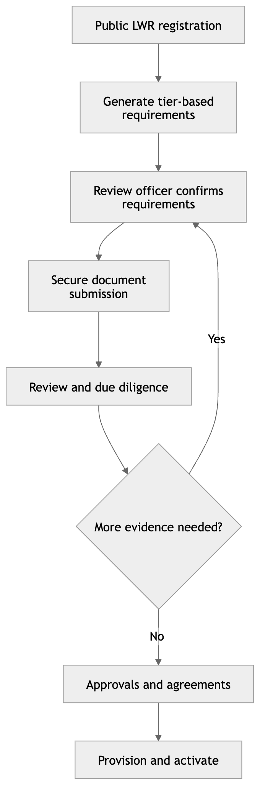
The distinction is important:
- Requested tier determines an initial document baseline.
- Rules generate the requirements.
- The review officer confirms and supplements them.
- The applicant supplies evidence securely.
- The achieved tier is not guaranteed by the tier requested. It is confirmed only after evidence, assessment and approvals.
The existing solution should now explicitly include a pre-onboarding applicant workspace or secure upload mechanism between public registration and full partner-user provisioning.

